

**HFCT Applicant Process (Checklist)**

The Hamilton Family Charitable Trust (HFCT) **Applicant Process** consists of five stages. Each stage has detailed instructions and information to guide you through the required sections of the process. Please see the **HFCT** **Applicant Process & Stages** document for additional information.

1. Grant Eligibility
2. Letter of Intent
3. Common Grant Application & Proposed Budget
4. Board Decision
5. HFCT Follow-up

HFCT no longer accepts applications for funding on a rolling basis. If invited to apply, the application deadline and board decision dates can be found on HFCT [**website**](https://www.hfctrust.org/application-process/#deadlines). Please see our website for more detailed information [**www.hfctrust.org**](http://www.hfctrust.org).

**Before submitting your application, please see the Hamilton Helpful Hints below.**

* **Hint**: Please check our website [**www.hfctrust.org**](http://www.hfctrust.org) and click the **Application Process** tab for the latest information.
* **Hint**: The Trust will award grants three times in a calendar year. Select a grant cycle that aligns best with your program /project start and end dates. Once a cycle is selected, review the **timeline** for the chosen cycle.

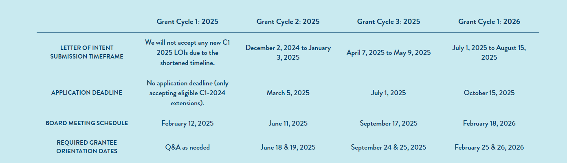

* **Hint:** Review Eligibility Requirements by region on the HFCT website. Select one of the tabs (illustrated) below for more information.
* **Hint**: Please make sure to obtain all required organizational, program, and fiscal documentation prior to starting your application.



* **Hint**: Create Foundant Credentials. Foundant is our online grant system. Once you have Foundant credentials, you will need to identify a primary contact for your organization. The primary contact will receive all HFCT communications.

**Important Note:**

The primary contact is a critical role for your organization. **Contact HFCT if the primary contact changes or needs to be updated within the Foundant system.** Failure to update this information may cause delayed or missed communication regarding your grant.

Ready to Apply? Please log in to the Foundant Online Grant System.