

**HFCT APPLICANT PROCESS & STAGES**

**How to Apply for Funding**

The Hamilton Family Charitable Trust (HFCT) Applicant Process consists of five stages.  Each stage has detailed instructions and information to guide you through the required sections of the process.

HFCT no longer accepts applications for funding on a rolling basis. If invited to apply, the application deadline and board decision dates can be found on HFCT [**website**](https://www.hfctrust.org/application-process/#deadlines)**.** Please see our website for more detailed information [**www.hfctrust.org**](http://www.hfctrust.org/)**.**

If you are a **new** HFCT applicant, please see the: **HFCT Applicant Process (Checklist)** for pre-applicant information before applying.

**HFCT APPLICANT PROCESS & STAGES:** (PRE-BOARD DECISION)

HFCT will **only** process applications submitted via our online portal. Please be sure to save your online application draft intermittently as you work through it. Once your application is received, program staff will contact you if additional information is required.  Your organization will receive a response after the Board Meeting date for your cycle. All board decision dates can be found on our [**website**](https://www.hfctrust.org/application-process/#deadlines).

**1. Determine Grant Eligibility**

To determine grant eligibility, please **TAKE OUR ELIGIBILITY QUIZ**: A link to the eligibility quiz can be found on your Applicant Dashboard.

**2. Submit a Letter of Intent (LOI) for the intended application cycle**

The Letter of Intent (LOI) is an online form in our grant management system, Foundant. All requests for funding must be submitted by 11:59 pm on the specified LOI deadline for your cycle. **Your LOI will then be reviewed to determine if your organization will be invited to submit the full application.**  Please review the LOI Instructions and Important information before completing each section (below).

Please answer all required LOI questions and click the **submit** button.  To complete the application, you must receive an **invitation to apply** notification from the President**.**

***Important Note:*** *Answers from the LOI questions will populate the application form automatically and are "read-only". Your invitation to apply is based on the answers provided in the LOI. The answers cannot be changed without approval from the President.*

**3A**. **Complete and** **Submit the Common Grant Application**

Once invited to apply, your application will appear as a draft in your applicant dashboard.  To complete the grant application, access your applicant dashboard. **Click “Edit Application**” to complete the full application.

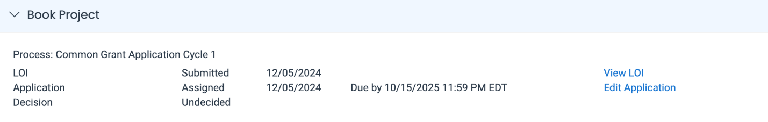

The common grant application is an online form in our grant management system, Foundant. All requests for funding must be submitted by 11:59 pm on the specified application deadline for your cycle. Please read and answer all required questions listed on the application.  \***You will not be able to submit the application unless all required questions have been answered*.**

**3B. Submit a Proposed Program or Project Budget with your Application.**

***Important Budget Notes:***

* *The Prior 2-year program budget is only required for project funding.  Approved Capital or General Operating requests are not required to submit the Prior 2-year Program Budget.*
* *Please click on each template to complete and submit the budget.* ***Failure to submit the financial information on the required template will result in an incomplete application****.*

Following a successful application submission, you will receive an email verification that your information was received.

**APPLICANT STAGES:** (POST-BOARD DECISION)

**4. Board Decision**

All applicants will receive a response after the Board Meeting date for your cycle. All board decision dates can be found on our [**website**](https://www.hfctrust.org/application-process/#deadlines).

**5.** **HFCT Follow-up**

Your organization’s **primary contact** will receive a formal notification communicating the Board’s decision within 72 hours of the meeting.  Please make sure HFCT has current contact information in the Foundant online grant system.

**Questions or Concerns**

Email [oe@hfctrust.org](mailto:oe@hfctrust.org) Attention: Application Process (Insert Cycle). **Ex: (Cycle Two)**